

Introduction to

Static Analysis Using

SolidWorks Simulation

®

Radostina V. Petrova

## CHAPTER 5

|  |
| --- |
| ***IMPACT OF MESH***  ***DENSITY AND VIEWING MODE ON FINAL RESULTS*** |

### 5.1 DIFFERENT TYPES OF FEs, REGARDING THE GEOMETRY OF THE MODEL

Based on the geometry of the model, there are a few different types of finite elements (FEs), adopted by SW Simulation – solid FEs, shell FEs and beam FEs. Otherwise, these types of FEs are known as spatial or 3D FEs, plane or 2D FEs and linear or 1D FEs. The program chooses the type of the FE, based on that geometrical criterion automatically, but the user can interact and change software’s decision if he/she finds this appropriate. Compared to some other commercial products for FE analysis, SW Simulation does not allow the user to select the type of the FEs. For example, all solid FEs are tetrahedrons (Figure 3.2), and no parallelepipeds or any other prismatic elements can be used. The program automatically creates the following meshes:

* **Solid Mesh** – suitable for bulky objects. The program creates a solid mesh with tetrahedral 3D solid elements for all solid components (Figure 5.1). The user chooses whether linear or parabolic FEs are to be applied.
* **Shell Mesh** – The program automatically creates a shell mesh for shell or plate structures with uniform thicknesses, for example. For sheet metals, the mesh is automatically created at the mid-surface (Figure 5.2a), and the program extracts the shell thickness from the thickness of the sheet metal (Figure 5.2). For other shell structures, there are different options, which can be assigned through the **Shell Definition** property manager and will be discussed later. By default, the top side of the shell is orange and the bottom is grey. This colour legend helps us to analyse easier the directions of the displacements, the positive, and the negative directions of shear stresses, etc. Of course, these colours can be changed (Figure 4.1b).

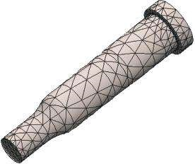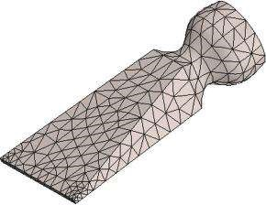

(

a

)

(

b

)

#### Fig u r e 5.1

*Mesh of solid FEs. (a) Solid m esh of a chisel; (b) solid m esh of a hole punch.*

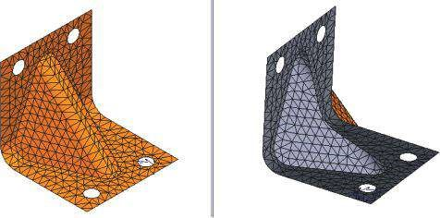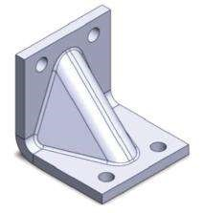

(

)

a

c

(

)

(

)

b

t/2

t

t = shell thickness

Meshed face

or surface

Elemen

t

#### Figure 5.2

*Mesh of shell FEs. (a) Sheet metal element (SW Simulation on-line help); (b) CAD model of a connecting part; (c) Shell m esh of a connecting part.*

* **Beam Mesh** – The program automatically uses beam mesh for interfering, touching or non-touching within a certain distance of structural elements. For the program, a beam element is a line element defined by two end points (joints) and a cross section. The joints between the elements (the points in magenta for connecting joints and in green for end joints in Figure 5.3) are identified automatically by the program or can be selected manually. There are truss and beam 1D FEs. Beam elements resist to axial, bending, shear and torsional loads, whereas truss elements resist to axial loads only (Figure 5.3).
* **Mixed Mesh** – The program automatically uses a mixed mesh when different geometries are present in the model.

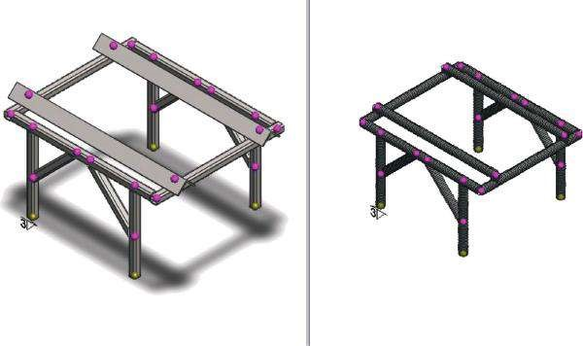

#### Figure 5.3

*CAD model and a mesh of a beam structure.*

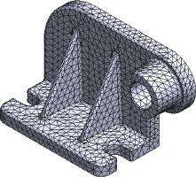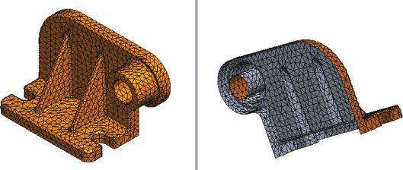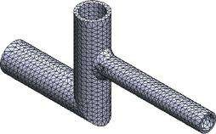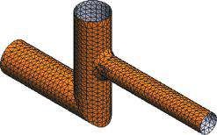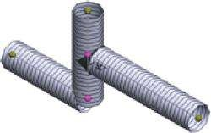

(

a

)

(

c

)

(

d

)

(

e

)

(

b

)

#### Figure 5.4

*CAD models and different types of FE mesh of parts. (a) Solid FE model of a part; (b) shell FE model of the same part – top and bottom views; (c) solid FE model of a welded part; (d) a shell FE model of the same part; (e) a beam FE model of the previous part.*

It is important to know that depending on the aim of the analysis, the geometrical model of the structure can be presented through different types of FEs in order to obtain the most appropriate results (Figure 5.4).

We learned about the different types of FEs used by SW Simulation, when meshing a model, in relation to its geometric properties.

We concluded that the user is responsible for selecting the correct type of FEs, yet the software helps them by suggesting the default size and the type of FEs in relation to certain build-in criteria.

|  |
| --- |
| We learned that there are three types of FEs in relation to the geometry of the model:   * Solid (3D) FEs – used for meshing bulky models * Shell (2D) FEs – used for meshing sheet metal-made structures * Beam (1D) FEs – used for meshing frames, made of structural elements   We know that each model can be meshed using different FEs, yet the final choice depends on the primary objective of the analysis. |

### 5.2 IMPACT OF MESH DENSITY, WHEN STANDARD SOLID MESH IS USED

As was already discussed in Chapter 3, when meshing solid bodies, the program enables the use of two basic types of mesh – standard mesh and curvature-based mesh. As was stated, this property of the elements is closely related to the number of nodes along the element edges and to the power of the polynomial, which transfers calculated node displacements to the displacements along the FE edges. Standard mesh uses FE, in which nodes are situated only in the vertexes of FE (Figure 3.2a). These are **first order** or **linear** elements, because the nodes are connected with straight edges, and the function that describes the displacements within the two vertex nodes (along the FE edge) is a first-order or a linear polynomial.

We will illustrate the impact of the standard mesh on the final results continuing with the analysis of the chisel from the previous chapters.

The first questions to be answered are as follows: How does the density of the mesh influence the computer time and the accuracy of the results? Can we find any optimal ratio or any other criteria, which are to be applied when setting the mesh density?

To answer these questions, we will come back to the first example: an alloy steel chisel, fixed at the root and loaded with two pressure loads – one at the cutting tip and one at the half of the bottom side of the chisel (Figure 2.49). We will discuss the final results from a new point of view.

#### 5.2.1 Coarse Mesh Calculations

At first, let us rename our study from **Study_1** to **Study_Coarse_Mesh**. To do so, we right click on the tab **Study_1** at the bottom bar (Figure 5.5a); then a pop-up menu (Figure 5.5b) opens and we left click on the **Rename** command. Thus, we directly rewrite the new name of the study **Study_Coarse_Mesh** in the tab (Figure 5.5c).

First, we have created a coarse standard mesh with the following properties: draft quality; element size –20 mm; tolerance –1 mm; total nodes –417; total elements –1352; maximum aspect ratio –4.4053; elements with aspect ratio <3 – 98.2%; elements with aspect ratio >10 – 0%; time to complete mesh –0:00:01h. Some plots of the mesh qualities are given in Figure 5.6 and some of the result plots in Figure 5.7.

Values of a few significant results (principal stresses, von Mises stress and displacements) are given in Table 5.1. As has already been said, the final values of some results (stress and strain, for example) depend on the mesh density and the mode (node or element mode). Thus, the two values are provided, and the quantity of the discrepancy value node mode −value element mode is calculated according to the formula δ% = ×100%. The

value node mode

(a) (b)

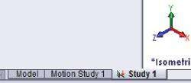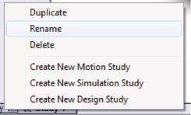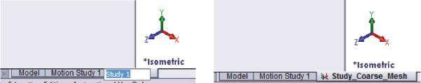

(

c

)

##### Fig u r e 5.5

*Renaming the m odel. (a) Tab with the old nam e; (b) pop-up m enu; (c) writing the new nam e directly on the old one.*

(a) (b)

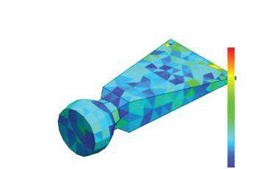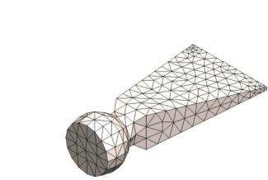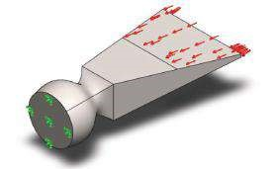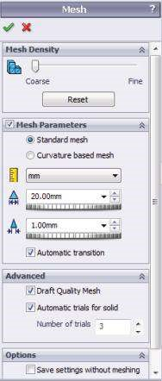

(

c

)

(

d

)

Model name: Chisel

Study name: Study 1

Plot type: Mesh Mesh Quality1

Model name: Chisel

Study name: Study 1

Plot type: Aspect ratio Mesh Quality2

Aspect Ratio

4.405e+000

4.130e+000

3.854e+000

3.579e+000

3.303e+000

3.026e+000

2.752e+000

2.477e+000

2.202e+000

1.926e+000

1.651e+000

1.375e+000

1.100e+000

##### Figure 5.6

*Coarse standard mesh model of the chisel. (a) Model of the chisel; (b) Mesh property manager; (c) coarse m esh of the chisel; (d) aspect ratio plot for the created m esh.*

P3 (N/mm2 (MPa))

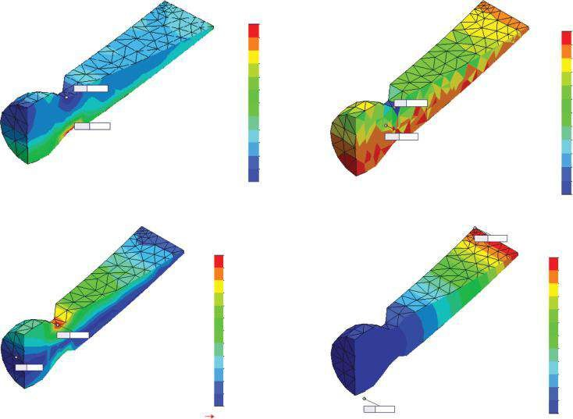

(

a

)

(

b

)

(

)

(

c

d)

P1 (N/mm

2

(MPa))

von Mises (N/mm

2

(MPa))

URES (mm)

96.7

86.1

–27.0

Min:

90.7

Max:

191.0

Max:

2.7

Min:

0.00

Min:

0.79

Max:

31.4

Max:

–357.1

Min:

76.1

65.8

55.5

45.2

34.9

24.6

14.2

3.9

–0.4

–16.7

–27.0

2.7

18.4

34.1

49.8

65.5

81.1

96.8

112.5

128.2

143.9

159.6

175.3

191.0

Yield strength: 620.4

0.00

0.07

0.13

0.20

0.26

0.33

0.39

0.46

0.52

0.59

0.66

0.72

0.79

31.4

–0.9

–33.3

–65.7

–98.1

–130.5

–162.8

–195.2

–227.6

–260.0

–292.4

–324.8

–357.1

##### Fig u r e 5.7

*Result plots for coarse standard m esh. (a) P1 plot (node m ode); (b) P3 plot (elem ent m ode); (c) von Mises plot (node m ode); (d) displacem ent plot (UREZ).*

***Table 5.1***

#### Coarse Standard Mesh Results

|  |  |  |  |  |
| --- | --- | --- | --- | --- |
|  | **Minimum** | **δ (% )** | **Maximum** | **δ (% )** |
| P1 (node mode) (MPa) | −26.97 | −138.0 | 96.70 | −98.0 |
| P1 (element mode) (MPa) | −64.22 |  | 191.47 |  |
| P3 (node mode) (MPa) | −222.61 | −60.4 | 13.38 | −135.1 |
| P3 (element mode) (MPa) | −357.14 |  | 31.45 |  |
| von Mises (node mode) (MPa) | 2.70 | −74.1 | 190.96 | −47.5 |
| von Mises (element mode) (MPa) | 4.70 |  | 281.60 |  |
| UZ (mm) | −0.04182 |  | 0.09745 |  |
| UREZ (mm) | 0.000 |  | 0.7867 |  |

calculated values show large discrepancies, some of them even larger than 100%. Therefore, it is hard to decide which of the stress values to trust; perhaps element mode values are more appropriate, considering the explanation about how they are calculated.

The conclusion is that the properties of the created mesh are necessary to be reconsidered.

##### 5.2.2 Fine Mesh Calculations

Until now, we have made an analysis using a coarse mesh. Unfortunately, we can hardly rely on the results for there are high discrepancies between the values achieved in the node mode and in the element mode, which is proved by the δ values given in Table 5.1.

Consequently, our next step is to perform the same analysis using a finer mesh. We have to **Create New Simulation Study** (Figure 5.8a) or to **Duplicate** the existing one (Figure 5.8b). If we choose to create a new study, we have to introduce the material, the fixtures and the loads again. Thus, it is chosen to duplicate the existing study. To do so, we right click on the simulation tab at the bottom bar. The tab is titled **Study_ Coarse_Mesh**, which is the name of the current study (Figure 5.8c). The **Default Configuration** to use will be kept. Finally, we click **OK**.

The main advantage of the duplicated study is that it has the same properties as the original analysis. Therefore, we will change the mesh properties only. The new mesh is a draft quality mesh (i.e. nodes at the vertexes of the tetrahedral FEs only) as was the first mesh; the element size, which is equal to 2 mm, and the tolerance, which is equal to 0.1 mm, are ten times smaller compared to those of the first mesh (Figure 5.9a and b). Thus, the total number of nodes increases to 107,781 and the total number of elements to 584,340. The maximum aspect ratio is 4.2196, that is, it is smaller compared to the first mesh ratio. The elements with aspect ratio < 3 are 99.9% versus 98.2% for the first mesh, while the elements with aspect ratio > 10 are 0% (Figure 5.9c). The reduction of the aspect ratio and the increase in the percentage of elements with aspect ratio < 3 are the criteria that show the better properties of this newly created mesh. On the contrary, the time to complete the mesh has increased from 0:00:01h to 0:01:13h; the time for running the analysis and the time for showing the plots on the monitor are the same. While running the analysis, we can see that the number of DoFs has also increased to 318,900.

(a) (b)

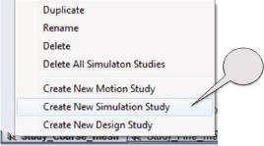

1

2

(c)

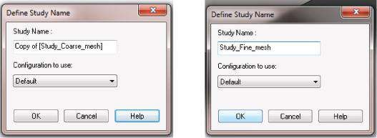

###### Figure 5.8

*How to duplicate an existing study. (a) Start a new study; (b) duplicate an existing study; (c) define the name of the duplicated study.*

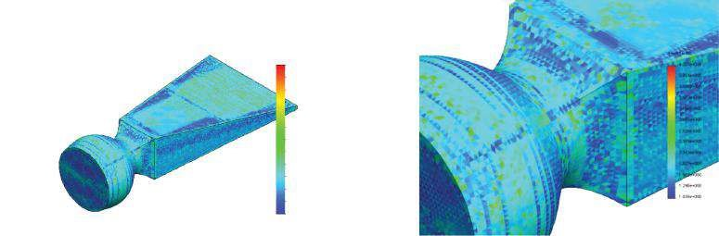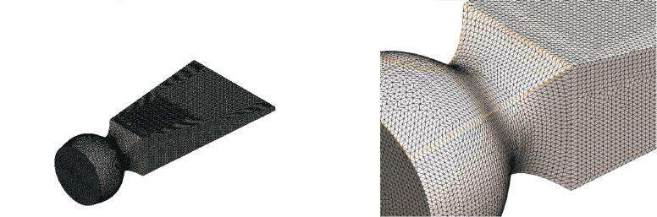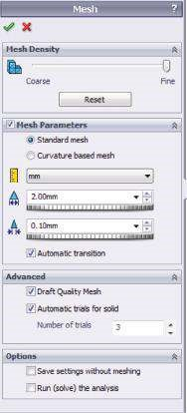

(

)

a

b

(

)

)

c

(

Mo

del name: Chisel

Study name: Study

1

Plot ty

p

e: Mesh Mesh

Qu

ality1

Mo

del name: Chisel

Study name: Study

1

Plot ty

p

e:

As

pect

ratio Mesh

Qu

ality

2

As

pect

Ra

ti

o

4.220e+00

0

3.954e+00

0

3.688e+00

0

3.422e+00

0

3.156e+00

0

2.891e+00

0

2.625e+00

0

2.359e+00

0

2.093e+00

0

1.827e+00

0

1.562e+00

0

1.296e+00

0

1.030e+00

0

Mo

del name: Chisel

Study name: Study

1

Plot ty

p

e: Mesh Mesh

Qu

ality1

Mo

del name: Chisel

Study name: Study

1

Plot ty

p

e:

As

pect

ratio Mesh

Qu

ality

2

***Figure 5.9***

*Coarse standard mesh model of the chisel. (a) Mesh property manager; (b) fine mesh of the chisel; (c) aspect ratio plot for the created mesh.*

While making this exercise, you have to bear in mind that some of the above-mentioned values (total nodes, total elements) can be different from those obtained by your solution depending on the algorithms of creating the mesh. But this is not crucial to the accuracy of the final results.

Thus, before discussing any of the results, we can conclude that we have improved the mesh but we have also increased the computing time.

A few plots of different results are given in Figure 5.10. The outlines of the plotted results are almost similar to the plots from the previous analysis (Figure 5.7), while the values differ significantly.

Table 5.2 summarises the fine mesh results. It is obvious that the discrepancies between the extreme values of the node and the element modes are reasonably reduced. This confirms our previous statement that the finer the mesh, the more accurate the results.

Yet, we cannot provide any quantitative parameter to measure the level of mesh improvement.

##### 5.2.3 Control Mesh Calculations

The version of the controlled mesh combines the advantages of the coarse mesh (quick calculations and minimum required computer resources) with those of the fine mesh (smaller elements, higher accuracy of the results), and as a result, it overcomes their main disadvantages.

(a) (b)

URES (mm)

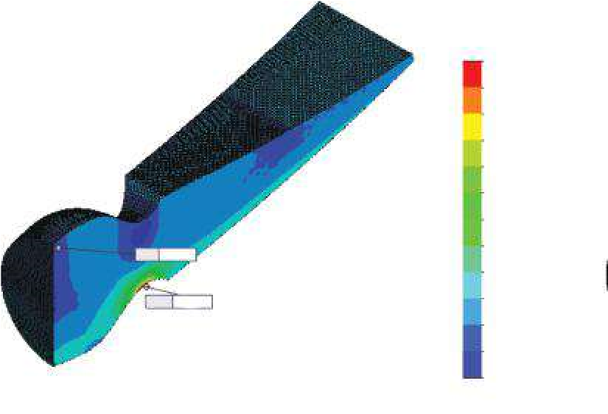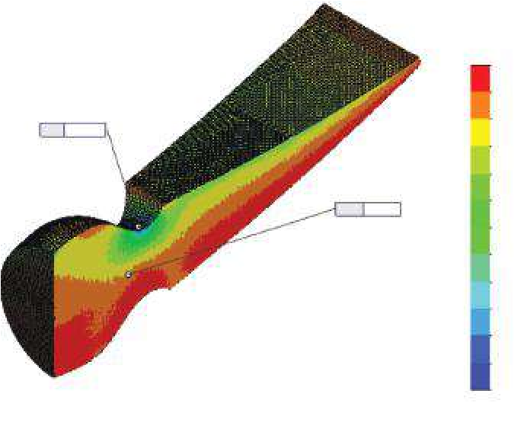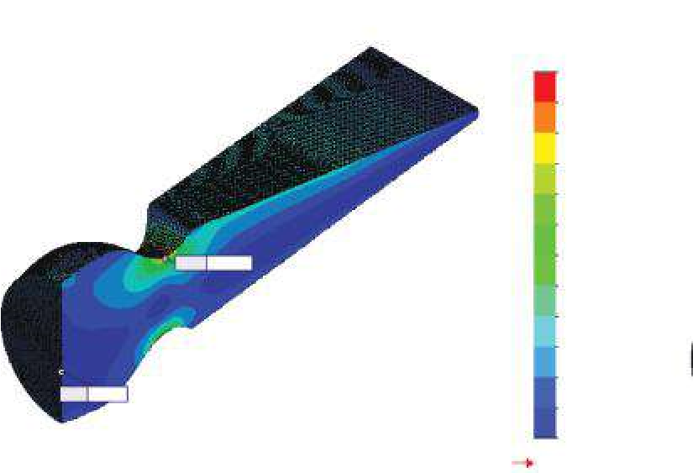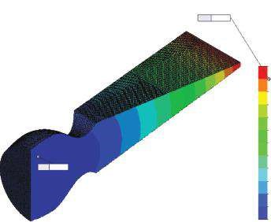

(

)

c

(

d

)

P1 (N/mm

2

(MPa))

P3 (N/mm

2

(MPa))

von Mises (N/mm

2

(MPa))

351.0

316.0

280.9

245.8

210.8

175.7

140.7

105.6

70..5

35.5

0.4

–34.7

–69.7

–633.1

–576.3

–519.5

–462.8

–406.0

–349.2

–292.5

–235.7

–178.9

–122.2

–65.4

–8.6

48.1

0.7

Yield strength: 620.4

43.9

87.1

130.3

173.5

216.7

259.9

303.0

346.2

389.4

432.6

475.8

519.0

–69.7

Min:

0.7

Min:

0.00

Min:

–633.1

Min:

48.1

Max:

1.18

Max:

Max:

351.0

Max:

519.0

1.18 1.08 0.98 0.89 0.79 0.69 0.59 0.49 0.39 0.30 0.20

0.10

0.00

###### Fig u r e 5.10

*Result plots for coarse standard m esh. (a) P1 plot (node m ode); (b) P3 plot (elem ent m ode); (c) von Mises plot (node m ode); (d) displacem ent plot (UREZ).*

***Table 5.2***

#### Fine Standard Mesh Results

|  |  |  |  |  |
| --- | --- | --- | --- | --- |
|  | **Minimum** | **δ (% )** | **Maximum** | **δ (% )** |
| P1 (node mode) (MPa) | −69.72 | −21.7 | 351.04 | −13.2 |
| P1 (element mode) (MPa) | −84.86 |  | 397.39 |  |
| P3 (node mode) (MPa) | −569.81 | −11.1 | 37.27 | −29.1 |
| P3 (element mode) (MPa) | −633.09 |  | 48.1 |  |
| von Mises (node mode) (MPa) | 0.700 | 29.2 | 519.0 | −6.8 |
| von Mises (element mode) (MPa) | 0.49522 |  | 554.34 |  |
| UZ (mm) | −0.070185 |  | 0.1246 |  |
| UREZ (mm) | 0 |  | 1.1809 |  |

At first, we duplicate **Study_Coarse_Mesh** according to the way described in Sections 5.2.1 and 5.2.2. The new study is titled **Study_Controlled_Mesh**.

Before starting to define the controlled mesh, it is recommended to make coarse mesh calculations to find where the vulnerable areas of the model are. Thus, we can create a denser mesh around those zones and a coarser mesh all over. As a result, we will have a fine-enough mesh in the vulnerable areas and a comparatively small number of elements/nodes. It is important to remind that the number of nodes is directly related to the number of DoFs, which itself equals the number of the solved equations. Therefore, the smaller this number, the quicker the calculations.

Based on our previous calculations, we know that the vulnerable areas are at the gudgeon of the chisel, that is, these are the areas where the extreme stresses are. Thus, we will reduce the size of elements there and leave the coarse mesh for the other areas. To do so, our first step is to find the narrowest cross section of the chisel, as follows:

1. Finding the intersection of the **Top Plane** and the two side faces of the root loft (Figure 5.11):

Sketch→Convert Entities→Intersection Curve

(a) (b)

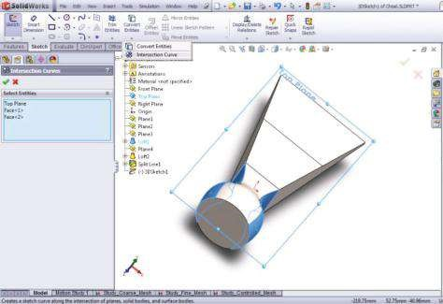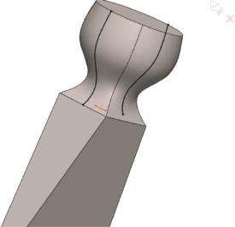

##### Fig u r e 5.11

*Intersection between Top Plane and two side faces of the root. (a) Defining intersection curve; (b) view of intersecting curves.*

1. Finding the narrowest section of the root. This is the cross section through the intersection point of the loft curve and the tangent to it (Figure 5.12).
2. Plotting a plane perpendicular to the axis of the chisel and through the newly defined intersection point (Figure 5.13):

Features →Reference Geometry →Plane

1. Defining the split contour – finding the intersection between Plane 5 and the side faces of the root loft (Figure 5.14):

Features→Curves→Split Line

(a) (b)

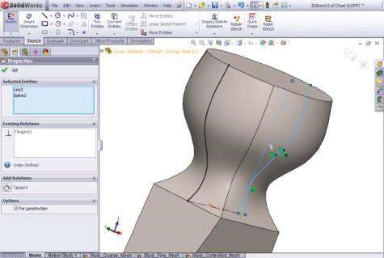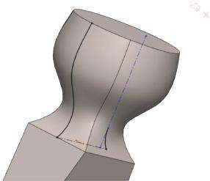

##### Fig u r e 5.12

*Finding the narrowest section of the chisel root* – *1. (a) Tangent relation between the construction line and the curve; (b) trimmed to the intersection point curve.*

(a) (b)

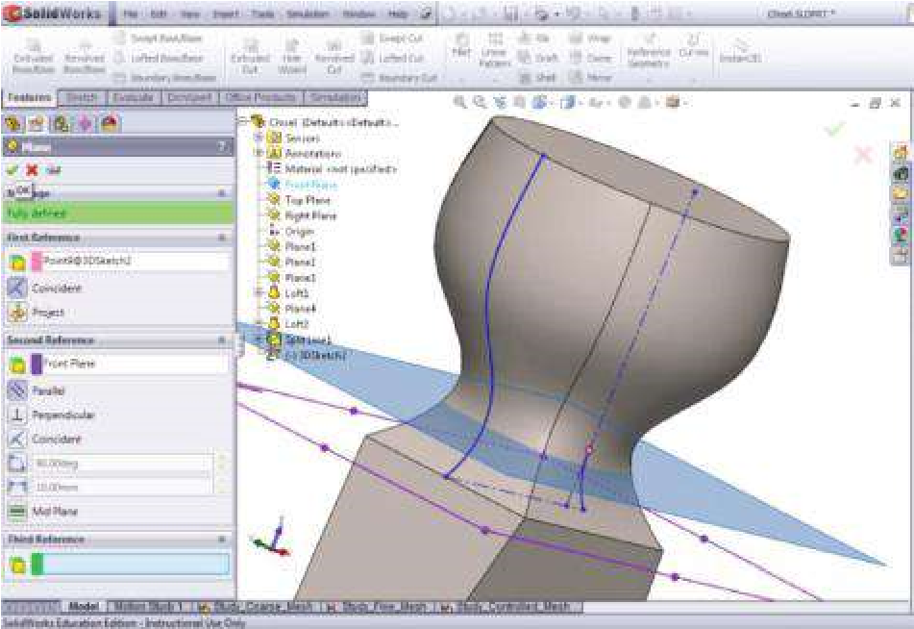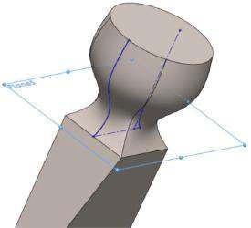

##### Fig u r e 5.13

*Defining the plane of the narrowest section of the chisel root* – *2. (a) Definition of a plane through the intersection point; (b) newly defined Plane 5.*

(a) (b)

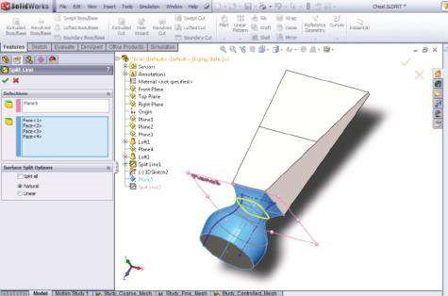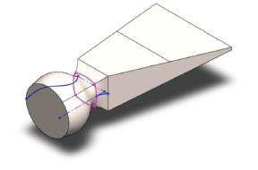

##### Fig u r e 5.14

*Finding the split contour of the narrowest section of the chisel root. (a) Definition of the split line between Plane 5 and the side faces; (b) contour of the split line* – *magenta line.*

Now we are ready to activate the **Mesh Control** command. As we used the **Duplicate** command to start this new study, the properties of the mesh had been copied. Thus, the current mesh consists of elements of size 20 mm and a tolerance of 1 mm, which is the same as those of the mesh of **Study_Coarse_Mesh**.

We will resize the mesh around the three contours shown in Figure 5.15. To do so, we start the **Mesh** pop-up menu from the analysis tree (Figure 3.3b) and left click **Apply Mesh Control** (, Figure 3.3b). The **Mesh Control** property manager opens (Figure 5.16). In the blue window **Select Entities**, the signatures of all picked by left clicking in the **Graphics area** entities/edges are displayed. We have chosen to make the mesh finer, targeting the three contours (Figure 5.16a–c). These three groups of edges define three separate **Controls**. The units, the size of the elements and the ratio of decrease are introduced through the **Mesh Property** sub-window. We set **Units** () to be millimetres and **Element size** () to be 2 mm as is the element size in **Study_Fine_Mesh** and **Ratio** (), which sets the ratio between the element size in the neighbouring layers to be 1.5. Approximately, this means that the element size of each next layer will be 50% less than the size of the elements from the previous layer. The properties of the entire mesh are kept as they have been set, that is, Units ( ) – mm; Global Size ( ) – 20 mm; and **Tolerance**

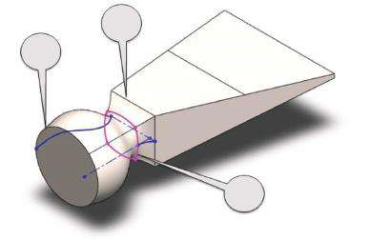

1

3

2

##### Fig u r e 5.15

*Drawing the split contour.*

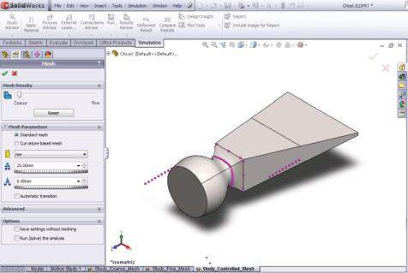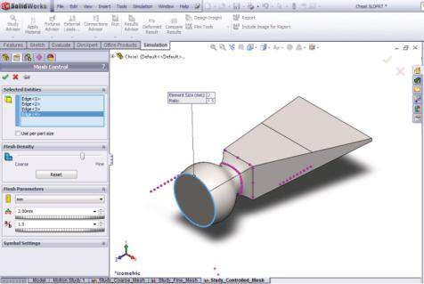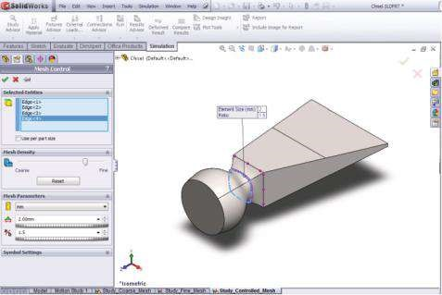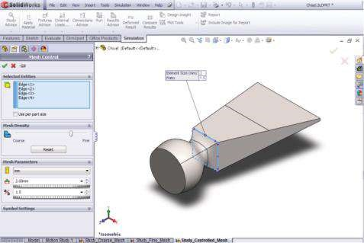

(

)

a

(

b

)

(

)

c

(

d

)

***Figure 5.16***

*Defining the mesh control edges. (a) Defining the controlled edges of the first contour; (b) defining the controlled edges of the second contour; (c) defining*

*the controlled edges of the third contour; (d) properties of the mesh without mesh control.*

(a)

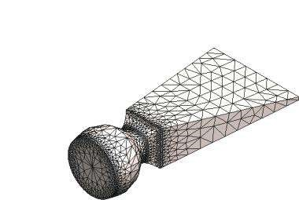

Mo

del name: Chisel

Study name: Study_Controlle

d_Mesh

Plot ty

pe: Mesh Mesh Quality1

(b)

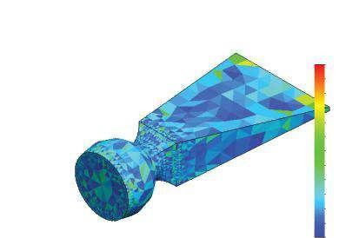

Mo

del name: Chisel

Study name: Study_Controlle

d_Mesh

Plot ty

pe: Aspect ratio Mesh Quality2

Aspect Ratio

6.827e+000

6.344e+000

5.860e+000

5.376e+000

4.892e+000

4.409e+000

3.925e+000

3.441e+000

2.958e+000

2.474e+000

1.990e+000

1.506e+000

1.023e+000

##### Fig u r e 5.17

*Quality plots of the controlled m esh. (a) Plot of the controlled m esh; (b) aspect ratio of the controlled mesh.*

() – automatically set by the program to 0.5. The size of the elements equals the size of the elements in **Study_Coarse_Mesh**.

In conclusion, we can say that a combination of the mesh properties of the two previous analyses has been created (Figure 5.17a).

The new mesh consists of 3401 **total nodes** and 14,885 **total elements**, and the **percentage of elements with aspect ratio <3** is 96.7%. The computer time for meshing the model is 0:00:03h. The single worse mesh property is the higher value of the **maximum aspect ratio** (6.8273, Figure 5.17b).

Finally, some results of the calculations with controlled standard mesh are plotted (Figure 5.18), and some results are summarised in Table 5.3 as it is done for both previous case studies.

It is obvious that the extreme, dangerous values are closer to those obtained through fine mesh calculations; some discrepancy values δ still remain high.

##### 5.2.4 Comparison of Results and Conclusions

To enrich the compared data, a fourth case study is set. It repeats the third scenario, but the size of the smallest elements is set to 1 mm (Figure 5.19a), and as a result, the **Tolerance** is reduced to 0.3 compared to 0.5 for the previous mesh. The mesh consists of 7274 nodes and 31,534 elements. It is created for 0:00:07h. The **percentage**

2

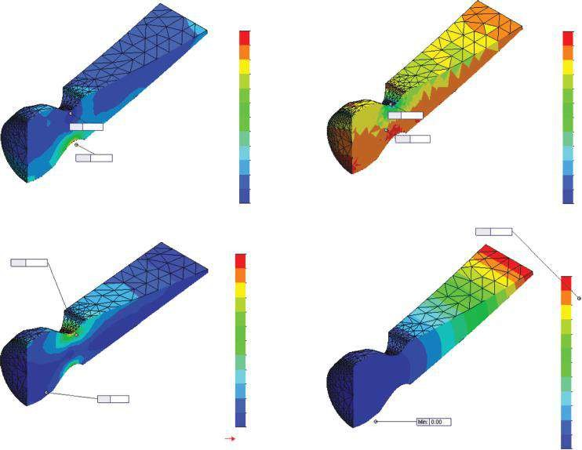

(

a

)

(

b

)

c

(

)

(

d)

P1 (N/mm

2

(MPa))

P3 (N/mm

(MPa))

von Mises (N/mm

2

(MPa))

URES (mm)

357.0

322.2

287.4

252.7

217.9

183.1

148.3

113.6

78.8

44.0

9.2

–25.5

–60.3

1.9

Yield stregth: 620.4

43.5

85.0

126.5

168.0

209.5

251.0

292.5

334.0

375.5

417.0

458.5

500.0

0.00

0.08

0.16

0.24

0.32

0.41

0.49

0.57

0.65

0.73

0.81

0.89

0.97

Min:

Max:

–60.3

357.0

Min:

Max:

–632.4

61.9

Max:

0.97

Min:

Max:

1.9

500.0

0.00

Min

:

61.9

4.0

–53.8

–111.7

–169.5

–227.4

–285.3

–343.1

–401.0

–458.8

–516.7

–574.5

–632.4

###### Fig u r e 5.18

*Result plots for controlled standard m esh. (a) P1 plot (node m ode); (b) P3 plot (elem ent m ode); (c) von Mises plot (node m ode); (d) displacem ent plot (UREZ).*

##### Table 5.3

**Controlled Standard Mesh Results (Element Size 20 to 2 mm)**

|  |  |  |  |  |
| --- | --- | --- | --- | --- |
|  | **Minimum** | **δ (% )** | **Maximum** | **δ (% )** |
| P1 (node mode) (MPa) | −60.30 | −118.4 | 357.00 | −9.9 |
| P1 (element mode) (MPa) | −131.70 |  | 392.20 |  |
| P3 (node mode) (MPa) | −550.33 | −14.9 | 33.07 | −87 |
| P3 (element mode) (MPa) | −632.41 |  | 61.89 |  |
| von Mises (node mode) (MPa) | 1.94 | 6.7 | 500.03 | −5.6 |
| von Mises (element mode) (MPa) | 2.07 |  | 527.87 |  |
| UZ (mm) | −0.06550 |  | 0.114317 |  |
| UREZ (mm) | 0 |  | 0.974802 |  |

**of elements with aspect ratio <3** is a little bit smaller (96.4% vs. 96.7%), while the **maximum aspect ratio** is significantly reduced (5.8503 vs. 6.8273; Figure 5.19b).

The results of the four case studies are given in Table 5.4. The trend is as follows: As the size of the elements decreases, the discrepancies between the extreme values for the case studies also decrease. The controlled mesh combines the quick calculations as a direct consequence of the reduced number of nodes with a higher accuracy of the results – the

(a)

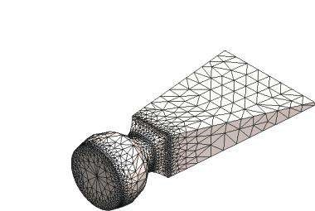

Mo

del name: Chisel

Study name: Study_Controlle

d_Mesh

Plot ty

pe: Mesh Mesh Quality1

(b)

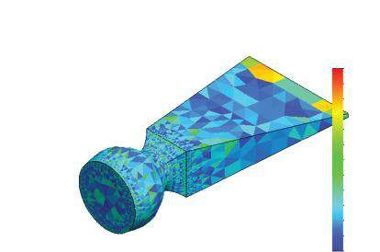

Mo

del name: Chisel

Study name: Study_Controlle

d_Mesh_1

Plot ty

pe: Aspect ratio Mesh Quality2

Aspect Ratio

5.850e+000

5.452e+000

5.053e+000

4.655e+000

4.257e+000

3.858e+000

3.460e+000

3.061e+000

2.663e+000

2.264e+000

1.866e+000

1.467e+000

1.069e+000

###### Fig u r e 5.19

*Properties of the controlled m esh (1 mm). (a) Plot of the controlled m esh; (b) aspect ratio of the controlled mesh.*

discrepancies between the fine mesh results and the controlled mesh results are significantly decreased, compared to the discrepancies between the coarse mesh results.

The last questions to be answered are as follows: Where is the vulnerable area? What are the true extreme values of the stresses and displacements?

No doubt that the vulnerable area is at the gudgeon of the chisel. Despite the chosen mesh density, all stress plots displace the extreme stresses in that area.

The discrepancies between the extreme stress values, regarding the mode of results view, vary significantly versus the mesh density. So, before making conclusions, it is better to filter the results. It is recommended to focus our attention to the positive values of **P1** to get an idea about the vulnerable areas exposed to tension. The maximum **P1** stresses appear in the gudgeon area, and if we exclude the coarse mesh results as inaccurate, we can see that discrepancies of the other sets are smaller than 15%. Even more, we can say that the element mode stress presentations show extreme tensile stresses in the range of 390 to 400 MPa, no matter what the chosen mesh density was*.* Almost similar is the justification considering the extreme compressive stresses (minimum **P3**). Based on the node mode presentation, their values vary from 550 to 590 MPa, while regarding the element mode view, the compressive stresses are up to 640 MPa. This could be a problem considering that the yield stress of the material is 620 MPa. But if the FEs’ size is reduced in the vulnerable area, we see that the compressive stress values reduce to 633.5 MPa for the element mode compared to 603 MPa for the node mode. Thus,

***Table 5.4***

**Compared Results of Different Case Studies**

**Minimum Values**

**Maximum Values**

**Type of Mesh**

**Coarse**

**Contr. 2 mm**

**Contr. 1 mm**

**Fine**

**Coarse**

**Contr. 2 mm**

**Contr. 1 mm**

**Fine**

P1 (node mode) (MPa)

−26.97

−60.30

−74.20

−69.72

96.70

357.00

376.50

351.04

P1 (element mode) (MPa)

−64.22

−131.7

−90.28

−84.86

191.47

392.2

400.45

397.39

Discrepancy

δ

(%)

−98.00

−9.86

−

***6.36***

−13.20

P3 (node mode) (MPa)

−222.61

−550.33

−590.89

−569.81

13.38

33.07

39.41

37.27

P3 (element mode) (MPa)

−357.14

−632.41

−646.35

−633.09

31.45

61.89

55.33

48.1

Discrepancy

δ

(%)

−60.43

−14.91

−

***9.39***

−11.11

von Mises (node mode) (MPa)

2.70

1.94

1.54

0.700

190.96

500.03

532.14

519.0

von Mises (elem. mode) (MPa)

4.70

2.07

1.22

0.49522

281.60

527.87

559.15

554.34

Discrepancy

δ

(%)

−47.46

−5.57

−

***5.08***

−6.81

UZ (mm)

−0.0418

−0.0655

−0.0666

−0.0702

0.0975

0.1143

0.1153

0.1247

UREZ (mm)

0.7867

0.9748

0.9941

1.1809

depending on the functions of the analysed object, on its importance within the entire production and on its price, the designer decides whether to leave the chisel as it is or to perform some constructive optimisation focusing on the diameter and the curvature of the vulnerable zone. As for the analysed object, the factor of safety is larger than 1, and considering the other criteria, such as the price and the level of reliability and safety of the chisel, the design is preserved and no optimisation activities are planned.

In this section, we solved four case studies based on a standard FE mesh.

We generated a coarse mesh, a fine mesh and both controlled meshes.

Comparing the results and the necessary computer time, it is undoubtedly proved that the controlled mesh is the optimal solution if the controlled entities are correctly selected (Figure. 5.16). The controlled entities can be vertexes, edges or faces. To decide which entities to be controlled, it is recommended to develop a coarse mesh study (Figure 5.7) at first to outline the vulnerable areas.

|  |
| --- |
| We learned how to generate different types of standard meshes of solid FEs and compared their advantages and shortcomings. We learned how to create a controlled mesh and defined a criterion on how to choose the controlled entities. The suggested algorithm starts with   * Coarse mesh analysis to outline the vulnerable area. * Controlled mesh analysis, where the choice of controlled meshed entities is based on the previous stage. * Second controlled mesh analysis, where the maximal size of the controlled FEs is half the size of the FEs in the previous stage; comparison of both controlled mesh results. This stage is optional. * Reaching some conclusions about the accuracy of the obtained results and about the necessity of any design optimisation. |

### 5.3 IMPACT OF MESH DENSITY, WHEN CURVATUREBASED SOLID MESH IS USED

#### 5.3.1 Development of CAD Model of Hole Puncher

The curvature-based mesh is worthy to be used in the FEAs of objects with high curvature values.

Consequently, we have chosen to analyse a hole puncher in this chapter. Its geometry is more complex compared to the geometry of the chisel. There are some areas of high curvature. Thus, the use of curvature-based mesh is preferable.

At first, we will explain how to develop the 3D model of the hole puncher. It consists of three united bodies, each developed using **Sweep** and **Revolve** features. We start with sketching and sweeping the punching/bottom body (Figure 5.20). The stages to be fulfilled are

1. Sketching the puncher – **Sketch_2** in plane **XY** (Figure 5.20a)
2. Sketching the path – **Sketch_1** in plane **XZ** (Figure 5.20b)
3. Sweeping **Sketch_2** along the path in **Sketch_1** (Figure 5.20c and d)

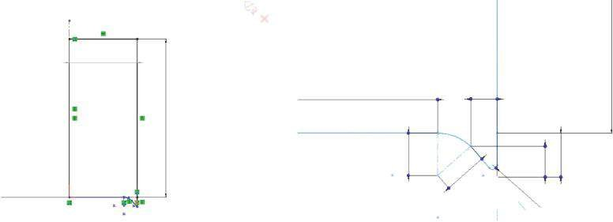

(

a

)

6.850

5.500

0.600

0.961

0.700

1

1

R0.100

16

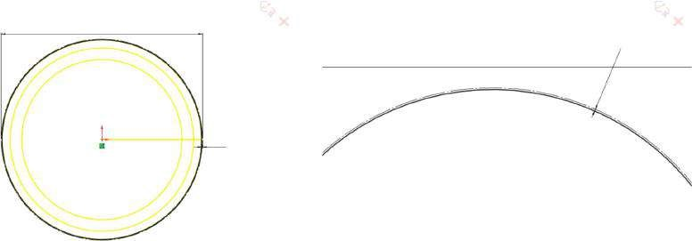

(

b

)

Ø13.800

Ø13.800

0.050

0.050

(c) (d)

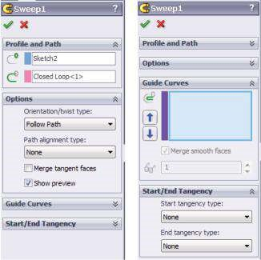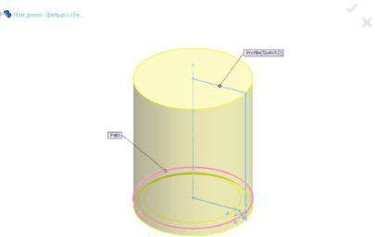

##### Figure 5.20

*Modelling the punching body. (a) Sketching the puncher – Sketch_2 in plane XY; (b) sketching the path – Sketch_1 in plane XZ; (c) options of Sweep property manager; (d) view of the swept sketch and the path.*

The next to be modelled is the root of the hole puncher. We start with

1. Sketching the root of the hole puncher *–* **Sketch_3** in plane **XY** (Figure 5.21a)
2. Revolving **Sketch_3** (Figure 5.21b–d)

The last to be modelled is the mid-body of the hole puncher. To develop its CAD geometry, we will run sketch and revolve functions:

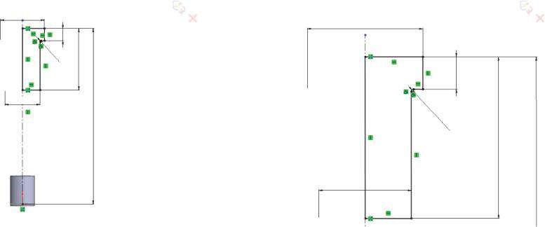

(

a

)

Ø25

Ø25

Ø20

35

10

0

7

R0.500

Ø20

R0.500

7

35

(b) (c) (d)

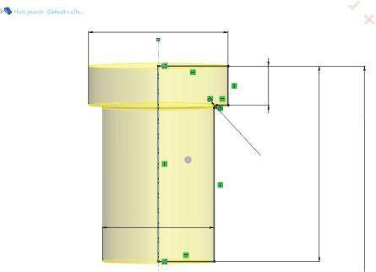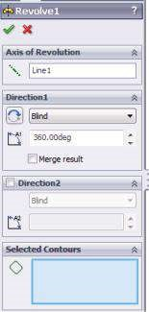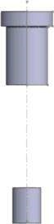

Ø25

7

35

Ø20

R0.500

##### Fig u r e 5.21

*Revolving the root of the hole puncher. (a) Sketching the root of the hole puncher – Sketch_3 in plane XY; (b) Revolve property manager; (c) Graphics area view of the revolving Sketch_3; (d) Revolved root.*

1. Sketching the mid-body *–* **Sketch_4** in plane **XY** (Figure 5.22a)
2. Revolving **Sketch_4** (Figure 5.22b–d)

The 3D model developed is shown in Figure 5.23, and therefore, we can start the static analysis.

#### 5.3.2 Development of Hole Puncher Model – Pre-Processor Stage

The first analysis to be done uses coarse mesh and its title is **Study_Coarse_Mesh**.

The material of the body is **alloy steel**. **Alloy steel** is a linear isotropic material with an elastic modulus of 210,000 MPa, Poison’s ratio equal to 0.28, mass density of 7700 kg/m3, tensile/compressive strength of 723.83 MPa and yield strength of 620.42 MPa.

Applied to the model fixtures are **Fixed Geometry** and **Roller/Slider** as shown in Figure 5.24.

(a)

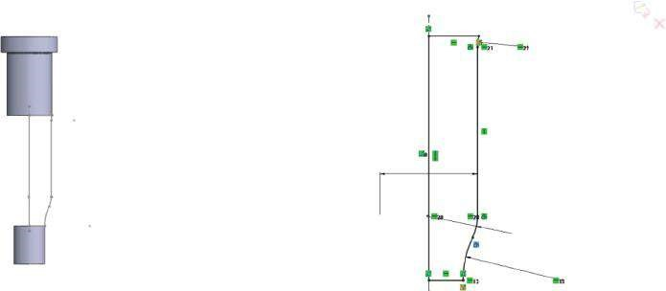

R10

Ø19.500

R10

R20

(b) (c) (d)

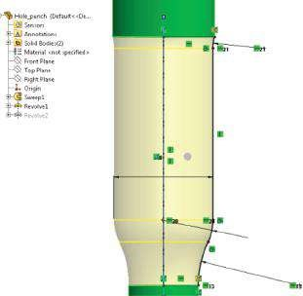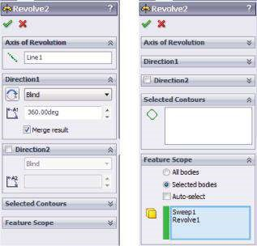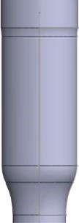

R10

Ø19.500

R1

0

R2

0

##### Figure 5.22

*Revolving the mid-body of the hole puncher. (a) Sketching the mid-body – Sketch_4 in plane XY; (b) Revolve property manager; (c) view of the revolving Sketch_4; (d) Revolved mid-body.*

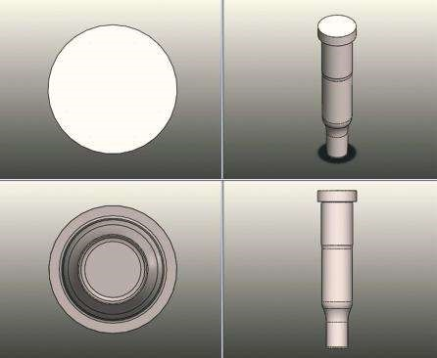

##### Figure 5.23

*Isometric, top, bottom and front views of the modelled hole puncher.*

(a) (b)

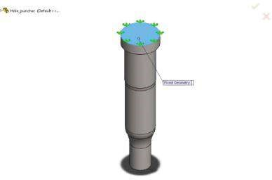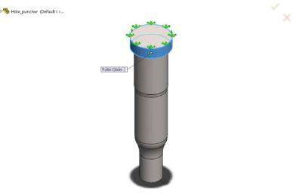

##### Figure 5.24

*Fixtures of the body. (a) Fixed Geometry fixture; (b) Roller/Slider fixture.*

The applied loads are **Gravity** (the red arrow) and **Force** (the magenta arrows in Figure 5.25). The gravity load is a volume-distributed load (N/m3), which is equal to the product of the earth’s acceleration (9.81 m/s2) and mass density (kg/m3). The force load (equal to 4000 N) is distributed across the face of the fillet of the punching edge load (N/m2). It is calculated as the value of the force divided by the area of the face. This load is parallel to the central axis of the hole puncher.

Regarding the FE model, that is, the mesh properties, we will try to keep the FE size as close as possible to the values assumed in Chapter 4.

#### 5.3.3 Coarse Mesh Calculations

**5.3.3.1 Scenario 1** A coarse mesh with the following properties is created (Figure 5.26): **curvature-based** **mesh** with 4 Jacobian points; Max Element Size –20 mm and Min Element Size –1 mm; Mesh quality – high; total nodes –13,931; total elements –8638; maximum aspect ratio –142.4; percentage of elements with aspect ratio <3 – 92.8%; percentage of elements with aspect ratio >10 – 2.1%; percentage of distorted element (Jacobian) –0%; time to complete mesh –0:00:02h.

Even before running the analysis, it can be said that the created mesh is not very well constructed as the maximum aspect ratio is large and about 2% of the elements

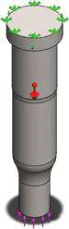

##### Fig u r e 5.25

*Applied loads.*

(a) (b)

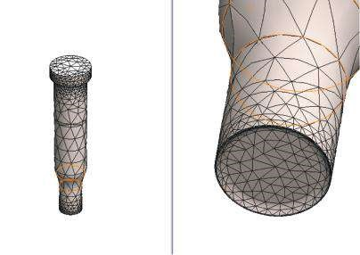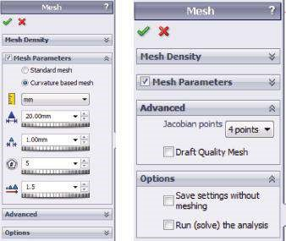

Model name: Hole_puncher

Study name: Study_Coarse_Mesh

Plot type: Mesh Mesh Quality1

Model name: Hole_puncher

Study name: Study_Coarse_Mesh

Plot type: Mesh Mesh Quality1

(c) (d)

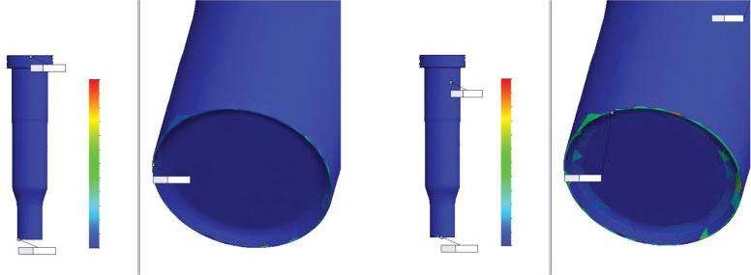

Aspect Ratio

142

131

119

107

95.3

83.5

71.7

60

48.2

36.4

24.6

12.8

1.07

Jacobian

15.2

14

12.8

11.7

10.5

9.29

8.11

6.92

5.74

4.55

3.37

2.18

1

Min: 1

Max: 142

Min: 1.07

Max: 142

Max: 15.2

Max: 15.2

Min: 1

##### Figure 5.26

*Properties of Coarse_Mesh – scenario 1. (a) Mesh property manager; (b) mesh plots; (c) aspect ratio plots; (d) Jacobian plots.*

have aspect ratio > 10. Further, these elements can lead to some inaccurately calculated values. It is good that there are no distorted elements. The distorted elements and the elements with a large aspect ratio are a perquisite for lower accuracy of the final results. The aspect ratio, larger than 3, could be a real problem within the calculations.

Some plots and results for **Coarse_Mesh** – **scenario 1** are shown in Figure 5.27 and in Table 5.5. Discrepancies between the node and the element mode are calculated value node mode −value element mode according to the node mode values, that is, δ% = ×100%.

value node mode

**5.3.3.2 Scenario 2** Now, a finer, yet, coarse mesh is created (Figure 5.28): curvaturebased mesh with 16 Jacobian points; max element size –10 mm and min element size –0.5 mm; total nodes –31,450; total elements –19,749; maximum aspect ratio –154.28 (larger compared to the previous scenario); percentage of elements with aspect ratio <3 – 94.7%; percentage of elements with aspect ratio >10 – 1.07%; percentage of distorted element (Jacobian) –0%; Time to complete mesh –0:00:03h. Despite the rise of the maximum aspect ratio, the percentage of elements with aspect ratio < 3 increases

(a)

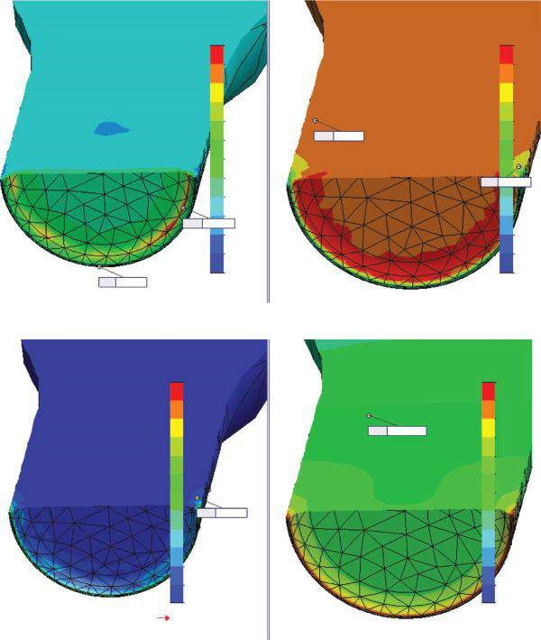

(

b

)

Max: 214.33

Min: –75.30

Min: –586.89

Max: 614.18

von Mises (N/mm^2 (MPa))

614.18

563.01

511.84

460.68

409.51

358.35

307.18

256.01

204.85

153.68

102.51

51.35

0.18

UY (mm)

0.00869

0.00796

0.00724

0.00651

0.00579

0.00507

0.00434

0.00352

0.00290

0.00217

0.00145

0.00072

0.00000

60.05

P3 (N/mm^2 (MPa

)

P1 (N/mm^2 (MPa)

6.13

–47.78

–101.6

–155.6

–209.5

–263.4

–317.3

–371.2

–425.1

–497.0

–532.9

–586.8

214.33

190.19

166.06

141.92

117.78

93.65

69.51

45.38

21.24

–2.90

–27.03

–51.17

–75.30

Yield strength: 620.42

Max: 0.00869

Max: 60.5

##### Fig u r e 5.27

*Result plots for scenario 1. (a) P1 and P3 stress plots in node mode; (b) von Mises plot in node m ode (on the left) and UY displacem ent (on the right).*

***Table 5.5***

#### Coarse Mesh Scenario 1 – Results

**Extreme Values of Some Stresses and Displacements for Scenario 1**

|  |  |  |  |
| --- | --- | --- | --- |
|  | **Node Mode** | **Element Mode** | **Discrepancy δ%** |
| P1 – min value (MPa) | −75.30 | −27.21 | 63.9 |
| P1 – max value (MPa) | 214.33 | 100.31 | 53.2 |
| P3 – min value (MPa) | −586.89 | −502.07 | 14.5 |
| P3 – max value (MPa) | 60.05 | 13.07 | 78.2 |
| von Mises – max value (MPa) | 614.18 | 525.26 | 14.5 |
| UY – max value (mm) | 0.00869 |  |  |
| UREZ – max value (mm) | 0.00938 |  |  |

(a) (b)

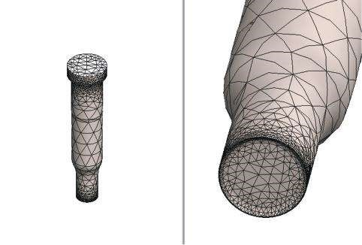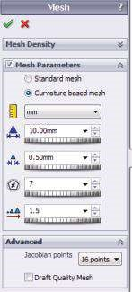

Model name: Hole_puncher

Study name: Study_Coarse_Mesh

Plot type: Mesh Mesh Quality1

Model name: Hole_puncher

Study name: Study_Coarse_Mesh

Plot type: Mesh Mesh Quality6

***Figure 5.28***

*Coarse mesh plot for scenario 2. (a) Mesh property manager; (b) mesh plot.*

***Table 5.6***

#### Coarse Mesh Scenario 2 – Results

**Extreme Values of Some Stresses and Displacements for Scenario 2**

|  |  |  |  |
| --- | --- | --- | --- |
|  | **Node Mode** | **Element Mode** | **Discrepancy δ%** |
| P1 – min value (MPa) | −29.66 | −13.75 | 53.6 |
| P1 – max value (MPa) | 217.65 | 108.05 | 50.4 |
| P3 – min value (MPa) | −635.91 | −535.99 | 15.7 |
| P3 – max value (MPa) | 71.49 | 23.23 | 67.5 |
| von Mises – max value (MPa) | 627.81 | 554.94 | 11.6 |
| UY – max value (mm) | 0.00881 |  |  |
| UREZ – max value (mm) | 0.00950 |  |  |

and the percentage of those with aspect ratio > 10 decreases; hence, the quality of the mesh is better.

Some results of the run analysis are provided in Table 5.6. They prove that for curvaturebased mesh, the decrease in the FE size causes quicker reduction of the discrepancies between the node and the element modes, compared to the same procedure for the standard mesh analysis.

##### 5.3.4 Fine Mesh Calculations

The general size of the second-order elements is assumed to be 2 mm with Jacobian points equal to the maximum provided by the software, that is, 29. Plots of this mesh are given in Figure 5.29. The mesh comprises 131,190 nodes and 85,186 elements. The maximum aspect ratio of 61.128 is related to a single badly configured FE. As a whole, all elements are well configured, and the percentage of those with aspect ratio < 3 is relatively high –98.9%. The percentage of FEs with aspect ratio > 10 is almost zero (0.00822%), and there is one distorted element (0.00117%). The necessary computer time to generate the mesh is 0:00:11h, a little bit longer compared to the two previous scenarios.

(a) (b)

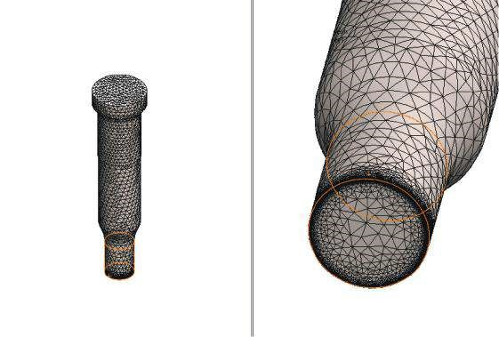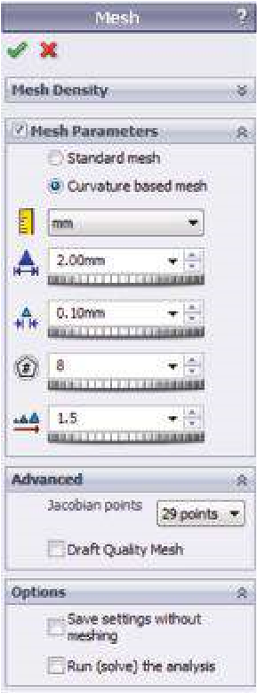

Model name: Hole_puncher

Study name: Study_Fine_Mesh

Plot type: Mesh Mesh Quality1

Model name: Hole_puncher

Study name: Study_Fine_Mesh

Plot type: Mesh Mesh Quality1

###### Figure 5.29

*Fine mesh plot. (a) Mesh property manager; (b) mesh plot.*

While running the analysis, a system of 391,569 equations is being solved for approximately 0:00:09h. Their number equals the number of DoFs of the model. The two principal stress plots, P1 for the highest tensile stresses and P3 for the highest compressive stresses, are shown in Figure 5.30, and the compared results are given in Table 5.7.

Contrary to our expectations, the discrepancies δ do not decrease. We will try to explain that fact, a few pages later, when we compare the standard mesh results to the curvature-based mesh results. Now it is enough to know that the observed consistency in the results is partially due to the geometry of the analysed part and partially due to the fact that the curvature-based mesh provides high accuracy even for FE of a larger size.

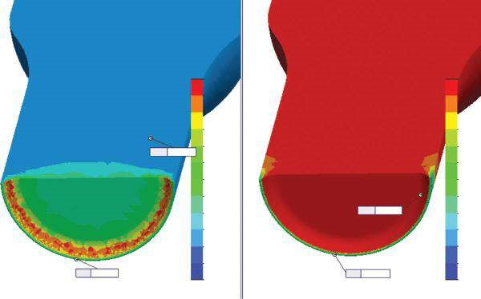

P1 [N/mm

2

(MPa)]

P3 [N/mm

2

(MPa)]

146.32

130.69

115.06

99.43

83.80

68.17

52.54

36.91

21.28

5.65

−9.99

−25.62

−41.25

16.22

−44.11

−104.4

−164.7

−225.0

−285.4

−345.7

−406.0

−466.3

−526.7

−587.0

−647.3

−707.6

Max:

146.32

Min:

−41.25

Max:

16.22

Min:

−707.67

***Fig u r e 5.30***

*Principal stress plot – element mode.*

***Table 5.7***

#### Fine Mesh Results

**Extreme Values of Some Stresses and Displacements for Fine_Mesh Scenario**

|  |  |  |  |
| --- | --- | --- | --- |
|  | **Node Mode** | **Element Mode** | **Discrepancy δ%** |
| P1 – min value (MPa) | −89.10 | −41.25 | 53.7 |
| P1 – max value (MPa) | 353.79 | 146.32 | 58.6 |
| P3 – min value (MPa) | −878.56 | −707.67 | 19.5 |
| P3 – max value (MPa) | 37.26 | 16.22 | 56.5 |
| von Mises – max value (MPa) | 964.45 | 647.98 | 32.8 |
| UY – max value (mm) | 0.00893 |  |  |
| UREZ – max value (mm) | 0.00965 |  |  |

As conclusion, it is enough to remember that the decrease in the element size is not a panacea to all problems regarding the model and does not always guarantee a quick convergence to the accurate values.

##### 5.3.5 Control Mesh Calculations

It is obvious that the most vulnerable area is the cutting edge of the hole puncher. Thus, it has been decided to decrease the element size of all FEs that are in its neighbourhood. Consequently, the control mesh will be applied to the cutting edge surroundings.

At first, we create a split line around the punching body (Figure 5.31). It duplicates **Sketch_1** (Figure 5.31a). The easiest way to create the split line is to open the **Split Line** property manager (Figure 5.31b):

Features→Curves→Split Line()

and to define the split line as an intersection of the **Top Plane** and the outer face of the punching body. The result is a new entity **Split Line3** (Figure 5.31c).

The next step is to generate mesh control properties. Two scenarios are designed.

**5.3.5.1 Scenario 3** This scenario uses a single **Mesh Control** option (Figure 5.32). The size of the elements of the blue-coloured faces (Figure 5.32a) is set to 0.5 mm, while the decreased ratio of two neighbouring element layers is 1.5. The maximum size of the rest of the FEs is 5 mm, and the minimum size of FEs is 0.5 mm. Jacobian points is 29 (Figure 5.32b).

The new curvature-based mesh consists of 190,797 nodes and 122,089 FEs. The maximum aspect ratio is 8.3045 (Figure 5.33b), and it is significantly reduced compared to the values of the previous scenarios. There are no badly configured elements – either distorted or elements with aspect ratio > 10, and the percentage of FE with an aspect ratio < 3 is the highest of all considered scenarios (99.2%). The time for mesh creation is also short (0:00:17h), because of the comparatively small controlled areas (Figure 5.33a).

The run analyses solve a model of 571,944 DoFs within 21 s.

A plot of the two extreme principal stresses, P1 and P3, is given in Figure 5.34. The numerical values of the results are in Table 5.8.

(a) (c)

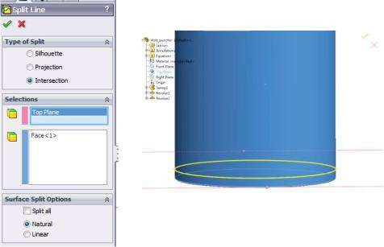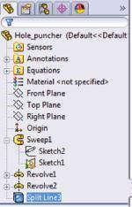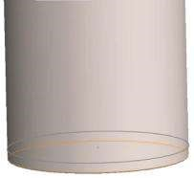

(

b

)

###### Fig u r e 5.31

*Generating Split Line around the punching body. (a) View of Sketch_1; (b) Split Line property m anager and graphic area view; (c) m odel tree.*

(a) (b)

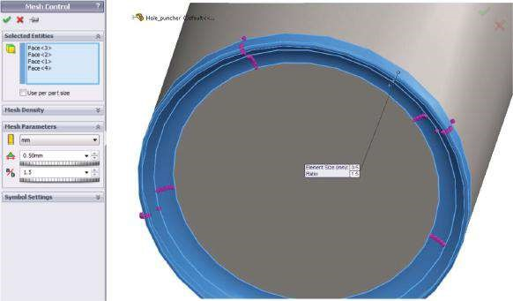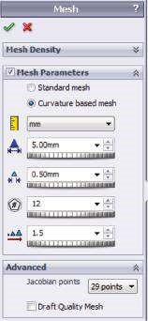

###### Fig u r e 5.32

*Defining mesh control and mesh properties. (a) Mesh Control property manager; (b) Mesh property m anager.*

(a) (b)

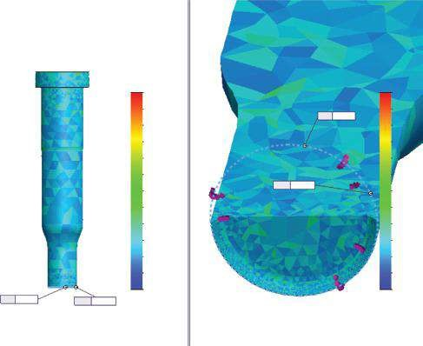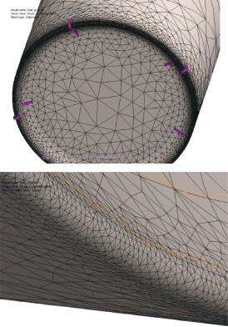

Aspect Ratio

8.3

7.61

6.92

6.23

5.54

4.84

4.15

3.46

2.77

2.08

1.38

0.692

0

Aspect Ratio

8.3

7.61

6.92

6.23

5.54

4.84

4.15

3.46

2.77

2.08

1.38

0.692

0

Min: 0

Max:

8.3

Max:

8.3

Min: 0

###### Fig u r e 5.33

*(a) Controlled mesh and (b) aspect ratio plots.*

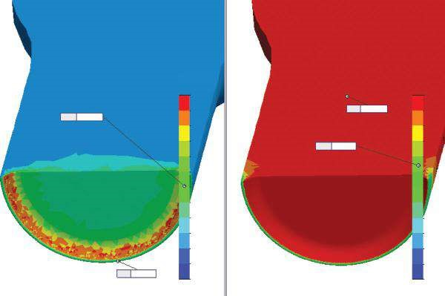

P1 [N/mm

2

(MPa)]

P3 [N/mm

2

(MPa)]

149.14

133.30

117.46

101.62

85.79

69.95

54.11

38.27

22.43

6.60

−9.24

−25.08

−40.92

14.52

−52.72

−119.9

−187.7

−254.4

−321.6

−388.8

−456.1

−523.3

−590.5

−657.8

−725.0

−792.2

Max:

149.14

Min:

−40.92

Max:

14.52

Min:

−792.29

###### Figure 5.34

*Principal stress plot – controlled mesh, element mode, scenario 3.*

Compared to the fine mesh case, some of the discrepancies between the two modes are significantly reduced, while the solution time and the use of computer resources increase a little.

Unfortunately, there are two values that grasp our attention. These are the extreme compressive stresses P3 and the maximum von Mises stress. Both values are interrelated as the von Mises stresses are calculated, regarding the P3 values

( σ *e* = (σ1 −σ2 )2 +(σ2 −σ3 )2 +(σ3 −σ1 )2 , see p. 104). The calculated values exceed 2

***Table 5.8***

#### Controlled Mesh Results – Scenario 3

**Extreme Values of Some Stresses and Displacements for Scenario 3**

|  |  |  |  |
| --- | --- | --- | --- |
|  | **Node Mode** | **Element Mode** | **Discrepancy δ%** |
| P1 – min value (MPa) | −55.59 | −40.92 | 26.4 |
| P1 – max value (MPa) | 179.93 | 149.14 | 17.1 |
| P3 – min value (MPa) | −1005.80 | −792.29 | 21.2 |
| P3 – max value (MPa) | 30.90 | 14.52 | 53.0 |
| von Mises – max value (MPa) | 891.88 | 727.49 | 18.4 |
| UY – max value (mm) | 0.00893 |  |  |
| UREZ – max value (mm) | 0.00965 |  |  |

even the compressive strength of the material. If we have measured the stresses in a physical model of the hole puncher, we would have observed two facts:

* The model does not destroy and is ready to operate even after such a loading; only some really small areas of the cutting edge are deformed.
* The highest measure compressive stresses are much smaller than the values calculated through FE analysis.

The explanation of that fact is quite simple if we consider the nature of both processes. While developing a FE model and further calculating the results, we do not take into consideration that the material itself transfers the loads across small areas, redistributes them more evenly across these areas and thus reduces the extreme stresses. The software is unable to do so; it calculates the stresses at the very node or FE. We must remind that the minimum FE size of the mesh is 0.5 mm, while the radius of the cutting edge is 0.1 mm (Figure 5.20a), which also reduces the accuracy of the FE model around the cutting edge area. The extreme compressive stresses appear in a very thin inconsistent strip at the outer face of the punching body. This allows us to assume that these large compressive stresses are a consequence of the calculating algorithms and the method’s assumptions.

**5.3.5.2 Scenario 4** The program builds the controlled mesh based on four different **mesh controls**.

The first **control** is related to the face of the cutting edge (Figure 5.35a) and sets the FE size to 0.1 mm, a value that equals the radius of the edge (Figure 5.20a). The second **control doubles** the FE size in the two neighbouring rings (Figure 5.35b). The third **control** increases the FE size to 0.3 mm for the second inner ring (Figure 5.35c), and the last **control** defines the FE size of the bottom face of the hole puncher to be 0.5 mm (Figure 5.35d).

The properties of the entire mesh are kept as they are in scenario 3; only the maximum FE size is reduced to 2 mm, and the minimum FE size is 0.4 mm (Figure 5.36a).

The new mesh possesses the following details: total nodes –231,594; total elements 150,693; max element size –2 mm; min element size –0.4 mm; maximum aspect ratio –8.526; percentage of elements with aspect ratio < 3 – 99.4%; % of distorted elements –0; time to complete mesh –0:00:23h (Figure 5.36b and c).

Running the analysis solves a FE model of 692,769 DoFs and takes about 25 s.

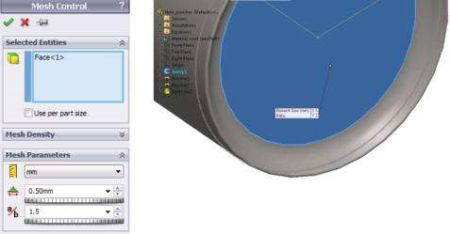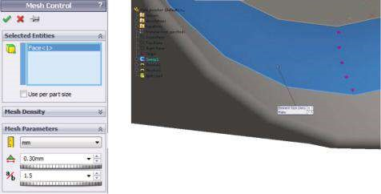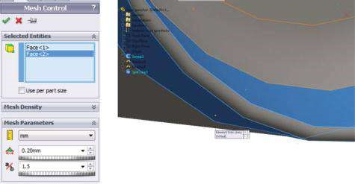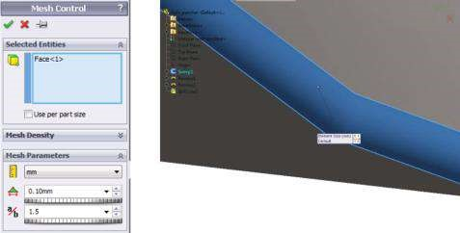

(

)

a

(

b

)

(

)

c

(

d

)

***Figure 5.35***

*Different controlled options. Controlled options for (a) Control 1; (b) Control 2; (c) Control 3; (d) Control 4.*

(a) (b)

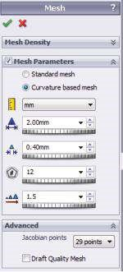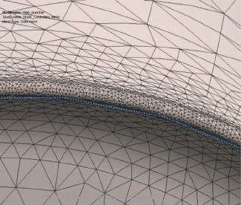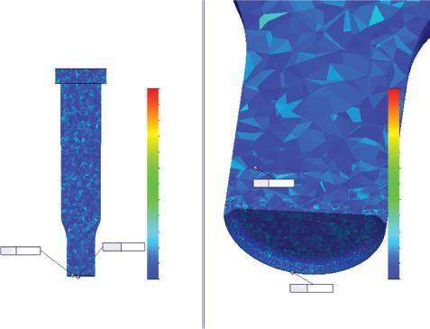

(

c

)

Aspect Ratio

8.53

7.9

7.28

6.65

6.03

5.4

4.78

4.15

3.53

2.91

2.28

1.66

1.03

Aspect Ratio

8.53

7.9

7.28

6.65

6.03

5.4

4.78

4.15

3.53

2.91

2.28

1.66

1.03

Max:

8.53

Min: 1.03

Min:

1.03

Max: 8.53

##### Fig u r e 5.36

*Mesh for scenario 4. (a) Mesh property manager; (b) mesh plot – controlled area; (c) aspect ratio plot.*

The **SW Simulation analysis tree** shows the four mesh controls and the final plots (Figure 5.37a). The principal stress plots are given in Figure 5.37b. Some of the results are presented in Table 5.9.

##### 5.3.6 Comparison of Results and Conclusions for Curvature-Based Mesh

Results of these five case studies are summarised in Tables 5.10 and 5.11. The trend of quicker convergence to the accurate results using comparatively limited computer resources when controlled mesh is used is even stronger in comparison to the standard mesh.

Yet the use of elements with a high **aspect ratio** sharply decreases the level of accuracy. The existence of distorted elements and the relatively small percentage of FEs with aspect ratio < 3 (see **Fine_Mesh** study) also make worse the quality of the created mesh. One of the possible solutions of that problem is the use of controlled

(a) (b)

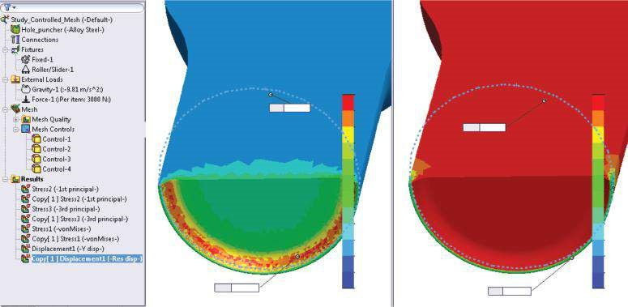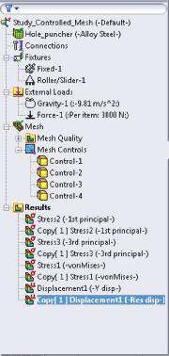

P1 [N/mm

2

(MPa)]

P3 [N/mm

2

(MPa)]

Min:

−44.53

150.74

134.47

118.20

101.92

85.65

69.38

53.10

36.83

20.56

4.29

−11.99

−28.26

−44.53

14.96

−49.10

−113.

1

−117.

2

−241.

2

−305.

3

−369.

4

−433.

4

−497.

5

−561.

6

−625.

6

−689.

7

−753.

7

Max:

14.96

Max:

150.74

Min:

−753.79

***Fig u r e 5.37***

*Results for scenario 4. (a) SW Simulation tree; (b) principal stress plots.*

***Table 5.9***

#### Controlled Mesh Results – Scenario 4

**Extreme Values of Some Stresses and Displacements for Scenario 4**

|  |  |  |  |
| --- | --- | --- | --- |
|  | **Node Mode** | **Element Mode** | **Discrepancy δ%** |
| P1 – min value (MPa) | −53.35 | −44.53 | 16.5 |
| P1 – max value (MPa) | 181.94 | 150.74 | 17.1 |
| P3 – min value (MPa) | −926.22 | −753.79 | 18.6 |
| P3 – max value (MPa) | 32.60 | 14.96 | 54.1 |
| von Mises – max value (MPa) | 858.10 | 696.28 | 18.9 |
| UY – max value (mm) | 0.00893 |  |  |
| UREZ – max value (mm) | 0.00965 |  |  |

***Table 5.10***

#### Extreme Values of Some Stresses and Displacements at Node Mode

**Coarse_Mesh Scenarios Controlled_Mesh Scenarios**

**Fine_Mesh**

|  |  |  |  |  |  |
| --- | --- | --- | --- | --- | --- |
|  | **Scenario 1** | **Scenario 2** | **Scenario** | **Scenario 3** | **Scenario 4** |
| P1 – min value (MPa) | −75.30 | −29.66 | −89.10 | −55.59 | −53.35 |
| P1 – max value (MPa) | 214.33 | 217.65 | 353.79 | 179.93 | 181.94 |
| P3 – min value (MPa) | −586.89 | −635.91 | −878.56 | −1005.80 | −926.22 |
| P3 – max value (MPa) | 60.05 | 71.49 | 37.26 | 30.90 | 32.60 |
| von Mises – max value (MPa) | 614.18 | 627.81 | 964.45 | 891.88 | 858.10 |
| UY – max value (mm) | 0.00869 | 0.00881 | 0.00893 | 0.00893 | 0.00893 |
| UREZ – max value (mm) | 0.00938 | 0.00950 | 0.00965 | 0.00965 | 0.00965 |

***Table 5.11***

#### Extreme Values of Some Stresses and Displacements at Element Mode

**Coarse_Mesh Scenarios Controlled_Mesh Scenarios**

**Fine_Mesh**

|  |  |  |  |  |  |
| --- | --- | --- | --- | --- | --- |
|  | **Scenario 1** | **Scenario 2** | **Scenario** | **Scenario 3** | **Scenario 4** |
| P1 – min value (MPa) | −27.21 | −13.75 | −41.25 | −40.92 | −44.53 |
| P1 – max value (MPa) | 100.31 | 108.05 | 146.32 | 149.14 | 150.74 |
| P3 – min value (MPa) | −502.07 | −535.99 | −707.67 | −792.29 | −753.79 |
| P3 – max value (MPa) | 13.07 | 23.23 | 16.22 | 14.52 | 14.96 |
| von Mises – max value (MPa) | 525.26 | 554.94 | 647.98 | 727.49 | 696.28 |

mesh, where the controlled entities are selected in the neighbourhood of the badly configured FEs’ areas.

Another interesting question that is yet to be answered treats the high stress values of min P3 and max von Mises in the node mode for the **Fine_Mesh** and **Controlled_Mesh** scenarios. It is obvious that values that are far beyond the yielding stress (620.42 MPa) and the tensile/compressive strength (723.83 MPa) are forbidden. Yet they exist, and even more, we do accept this phenomenon. This can be explained as follows:

1. These are case studies and we do not focus on achieving a certain factor of safety. But is this explanation convincing enough?
2. You can see that the extreme values appear and impact only very limited vulnerable zones. These high stresses do not spread around as it is in the real material, and the discrepancy between the extreme node values and the extreme element values is really high. The software calculates the element values in relation to all node values related to the calculated FE. Thus, if there is even a one large node value, it reflects the element value, and there is no way to consider that the rest of the node values are far below the yielding stresses. Yet such a large range of node values related to a single FE justifies the observed high discrepancies between the element mode and the node mode. Thus, the discussed extreme values are much more a consequence of our calculations than of the physical behaviour of the analysed object.
3. Another proof of our previous statement is the following fact: these values do not exceed the yielding strength for the first two cases, particularly for the element mode. Thus, they are strongly impacted by the chosen mesh properties, that is, it is time for the next question.

What is the optimal ratio between the mesh properties and the accuracy of the results? Unfortunately, there is no precise universal answer to that question, and I cannot provide here a brief instruction on the topic. The right choice is a matter of understanding and experience and a certain degree of intuition, which combines the designer’s practical and theoretical knowledge on the function of the structures.

We solved five case studies using a curvature-based mesh in this section.

Undoubtedly, we proved the advantages of the controlled mesh by using more than one mesh control.

We proved that the decrease in the element size is not the only possible and right way to achieve an accurate solution.

We focused our attention on some guidelines how to recognise the numerical spots, due to wrong modelling or analysis faults, from the real errors, based on wrong model development or misunderstanding of model operation.

We learned how to generate different types of curvature-based meshes.

We learned how to create a controlled mesh with more than one mesh control.

We discussed some guidelines how to pick out the numerical spots from the errors due to wrongly developed models and analysis.

### 5.4 IMPACT OF MESH DENSITY ON CALCULATION TIME AND ACCURACY

Now, it is time to discuss about the way in which mesh density influences the calculation time. It is important to know that this characteristic is rather partial as it is strongly influenced by the computer configuration – the more powerful the computer, the shorter that time.

The basic properties of all case studies for standard and for curvature-based meshes are systematised in Tables 5.12 and 5.13.

***Table 5.12***

#### Mesh Properties for Standard Mesh

**Controlled_Mesh Scenarios Coarse_Mesh Fine_Mesh**

|  |  |  |  |  |
| --- | --- | --- | --- | --- |
|  | **Scenario** | **Scenario** | **Scenario 1** | **Scenario 2** |
| Global Average Element Size (mm) | 20 | 2 | 20 | 20 |
| Tolerance (mm) | 1 | 0.1 | 0.5 | 0.3 |
| Max Controlled FE Size (mm) |  |  | 2 | 1 |
| Ratio between Neighbouring Layers |  |  | 1.5 | 1.5 |
| Total Nodes | 417 | 107,781 | 3401 | 7274 |
| Total Elements | 1352 | 584,340 | 14,885 | 31,534 |
| Maximum Aspect Ratio | 4.4053 | 4.2196 | 6.8273 | 5.8503 |
| Percentage of Elements with Aspect Ratio <3 (% ) | 98.2 | 99.9 | 96.7 | 96.4 |
| Percentage of Elements with Aspect Ratio >10 (% ) | 0 | 0 | 0 | 0 |
| Time to Complete Mesh (s) | 1 | 73 | 3 | 7 |

***Table 5.13***

#### Mesh Properties for Curvature-Based Mesh

**Coarse_Mesh Scenarios Controlled_Mesh Scenarios**

**Fine_Mesh**

|  |  |  |  |  |  |
| --- | --- | --- | --- | --- | --- |
|  | **Scenario 1** | **Scenario 2** | **Scenario** | **Scenario 3** | **Scenario 4** |
| Jacobian Points | 4 | 16 | 29 | 29 | 29 |
| Max Element Size (mm) | 20 | 10 | 2 | 5 | 2 |
| Min Element Size (mm) | 1 | 0.5 | 0.1 | 0.5 | 0.4 |
| Min Number of Elements in a Circle | 5 | 7 | 8 | 12 | 12 |
| Element Size Growth Ratio | 1.5 | 1.5 | 1.5 | 1.5 | 1.5 |
| Max Controlled FE Size (mm) |  |  |  | 0.5 | 0.1 ÷ 0.5 |
| Ratio between Neighbouring Layers |  |  |  | 1.5 | 1.5 |
| Total Nodes | 13,931 | 31,450 | 131,190 | 190,797 | 231,594 |
| Total Elements | 8639 | 19,749 | 85,186 | 122,089 | 150,693 |
| Maximum Aspect Ratio | 142.4 | 154.28 | 61.128 | 8.3045 | 8.526 |
| Percentage of Elements with Aspect Ratio <3 (% ) | 92.8 | 94.7 | 98.9 | 99.2 | 99.4 |
| Percentage of Elements with Aspect Ratio >10 (% ) | 2.10 | 1.07 | 0.00822 | 0 | 0 |
| % of D istorted Elements (Jacobian) (% ) | 0 | 0 | 0.0011711 | 0 | 0 |
| Time to Complete Mesh (s) | 2 | 3 | 11 | 17 | 23 |
| D oFs |  |  | 391,569 | 571,994 | 692,769 |
| Time to Solve the System(s) | 1 | 2 | 9 | 21 | 25 |

If we compare the calculation time for one and the same computer, we can make the following guiding conclusions:

* The denser the mesh is, the longer the calculations last, that is, the denser mesh is a perquisite for a larger total number of nodes, and consequently a larger number of DoFs and a larger number of solved equations.
* The standard mesh uses FEs of the first order, while the curvature-based mesh uses FEs of the second order. Thus, the total number of nodes, respectively, DoFs, corresponding to the equal total number of FEs for the standard mesh is smaller compared to those for the curvature-based mesh. Therefore, based on a relatively equal number of FEs, the standard mesh provides quicker solution, that is, uses smaller computer resources and time.
* Based on the higher order of the used FEs, the curvature-based mesh provides quicker convergence to the accurate results, as far as the mesh density is concerned.

***Table 5.14***

#### Extreme Stress Values’ Discrepancies for Standard Mesh Calculations (%)

**Controlled_Mesh Scenarios Coarse_Mesh Fine_Mesh**

|  |  |  |  |  |
| --- | --- | --- | --- | --- |
|  | **Scenarios** | **Scenario** | **Scenario 1** | **Scenario 2** |
| P1 – Min Value | −138.0 | −21.7 | −118.4 | −21.7 |
| P1 – Max Value | 98.0 | −13.2 | −9.9 | −6.4 |
| P3 – Min Value | −60.4 | −11.1 | −14.9 | −9.4 |
| P3 – Max Value | −135.1 | −29.1 | −87.0 | −40.4 |
| von Mises – Max Value | −47.5 | −6.8 | −5.6 | −5.07 |

***Table 5.15***

#### Extreme Stress Values’ Discrepancies for Curvature-Based Mesh Calculations (%)

**Coarse_Mesh Scenarios Controlled_Mesh Scenarios**

**Fine_Mesh**

|  |  |  |  |  |  |
| --- | --- | --- | --- | --- | --- |
|  | **Scenario 1** | **Scenario 2** | **Scenario** | **Scenario 3** | **Scenario 4** |
| P1 – Min Value | 63.9 | 53.6 | 53.7 | 26.4 | 16.5 |
| P1 – Max Value | 53.2 | 50.4 | 58.6 | 17.1 | 17.1 |
| P3 – Min Value | 14.5 | 15.7 | 19.5 | 21.2 | 18.6 |
| P3 – Max Value | 78.2 | 67.5 | 56.5 | 53.0 | 54.1 |
| von Mises – Max Value | 14.5 | 11.6 | 32.8 | 18.4 | 18.9 |

### 5.5 COMPARISON BETWEEN THE NODE MODE AND THE ELEMENT MODE

We already know that the mode selection (a node mode or an element mode) impacts only the presented results. The type of the chosen mode does not influence the calculation flow and accuracy of the results. In fact, this is a choice that affects the final presentation and the report. Based on what we have discussed in Sections 5.2 and 5.3, we can conclude that the element mode is better for presenting numerical values, graphs and plots. Additionally, based on the used techniques for the calculation of element values, that mode cuts the extreme picks that can appear in the node mode.

As the magnitudes/absolute values of the analysed properties become larger, the discrepancies between the node mode and the element mode become lower. The decrease in those discrepancies is strongly influenced by the absolute values of the compared properties than the density and the type of the mesh (Tables 5.14 and 5.15).

### 5.6 FINAL RECOMMENDATIONS ON SELECTION OF MESH TYPE

Here are some guidelines on how to choose the type and the properties of the mesh to be sure that your analysis is correct:

* Start with a standard mesh, accepting the properties the program suggests.
* If there is a high percentage of elements with an aspect ratio > 10 or a low percentage of elements with an aspect ratio < 3, try either to reduce the FE size or to change the type of the mesh to a curvature-based one. The second solution is recommended if you have a model with a complex geometry or if there are distorted (Jacobian) elements.
* Finally, as the software calculates the displacements first, the stresses are based on those data. Therefore, it is harder to achieve a high level for accuracy for the stresses than for the displacement (see the extreme displacement values for Fine_Mesh and Controlled_Mesh scenarios for the curvature-based mesh, which are equal but generate different extreme stresses).
* Always pay attention to the origin of the extreme stress values, and before continuing, try to explain their origin: are they due to the numerical algorithms and introduced mesh properties or due to mistakes in the model development and the consequent analysis?

We tried to compare the properties of standard and curvature-based meshes and write guidelines on how to start the solution, as far as the mesh creation is concerned.

Additionally, some recommendations on processing the analysis if the obtained results do not coincide with our expectations are given.

We learned how to assess the quality of the created mesh based on the final results and how to improve the accuracy of the results by changing the mesh properties.